

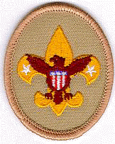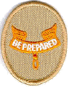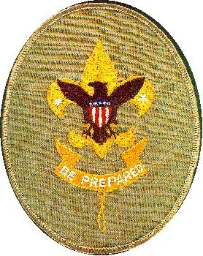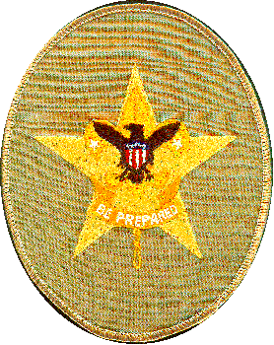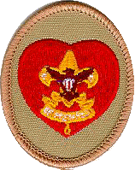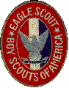
Date

Someone
Somewhere

Dear Sir:

I am currently planning an Eagle Service Project through the Boy Scouts in support of XXXX organization. The service will involve (description of project). The project is planned to be performed at (xxxxx) on (date....) by volunteers from Huntington Beach.

To help perform this project, I am soliciting donations from local businesses. Would it be possible for your business to support this community service project? In particular, I am looking for donations of (xxxxxxx)

For additional information I may be reached at (Provide your contact information here.... phone number, address and email).

My Scoutmaster is Bill Hencke, who may be reached at 714-336-0209 (phone number), and our Troop committee Chairman is Wally Mc Clure who may be reached at 714-814-4926

Sincerely,

Name

Approved: (someone from Troop)
.
Boy Scouts of America Huntington Beach California
Sponsored by the St. Bonaventure Men's Club

